Graph Theory
Graph approaches to data are exploding in the commercial world to better reveal meaning in data as well as forecast behavior of complex systems. This burst is due to the increasing connectedness of data, breakthroughs in scaling graph technology to enterprise-sized problems, excellent results when integrated with machine learning (ML) and artificial intelligence (AI) solutions, and more accessible tools for general analytics and data science teams.

Explaining What a Graph Is
Networks are a representation, a tool to understand complex systems and the complex connections inherent in today’s data. For example, you can represent how a social system works by thinking about interactions between pairs of people. By analyzing the structure of this representation, you can answer questions and make predictions about how the system works or how individuals behave within it. In this sense, network science is a set of technical tools applicable to nearly any domain, and graphs are the mathematical models used to perform analysis. Simply put, graphs are a mathematical representation of complex systems.
Graphs have a history dating back to 1736. The origins of graph theory hail from the city of Königsberg, which included two large islands connected to each other and the two mainland portions of the city by seven bridges. The puzzle was to create a walk through the city, crossing each bridge once and only once. Leonhard Euler solved that puzzle by asking whether it was possible to visit all four areas of a city connected by seven bridges, while only crossing each bridge once. It wasn’t.
With the insight that only the connections themselves were relevant to solving this kind of problem, Euler established the groundwork for graph theory and its mathematics. As one of Euler’s original sketches, Figure 1–1 depicts Euler’s progression:
» Walking the bridges of Königsberg: Four main areas of Königsberg with seven bridges. Can you cross each bridge only once and return to your starting point?
» Euler’s insight: The only relevant data is the main areas and the bridges connecting them.
» Origins of graph theory: Euler abstracted the problem and created generalized rules based on nodes and relationships that apply to any connected system.
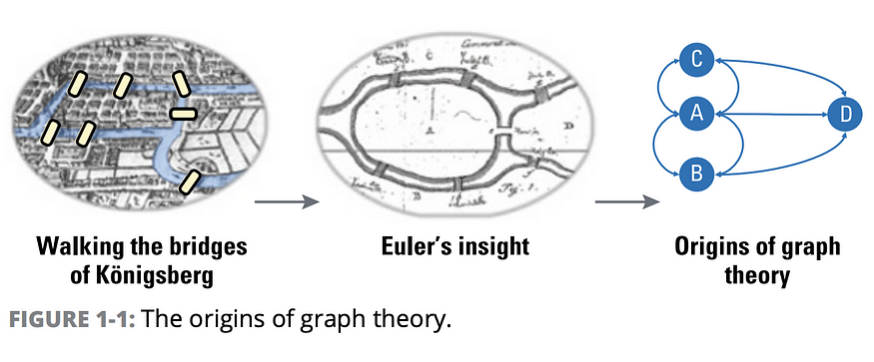
While graphs originated in mathematics, they are also a pragmatic and faithful representation of data for modeling and analysis. A graph is a representation of a network, often illustrated with circles to represent entities, also called nodes or vertices, and lines between them. Those lines are known as relationships, links, or edges. Think of nodes as the nouns in sentences, and relationships as verbs that give context to the nodes. To avoid any confusion, the graphs we talk about in this book have nothing to do with graphing equations or charts. Take a look at the differences in Figure 1–2.
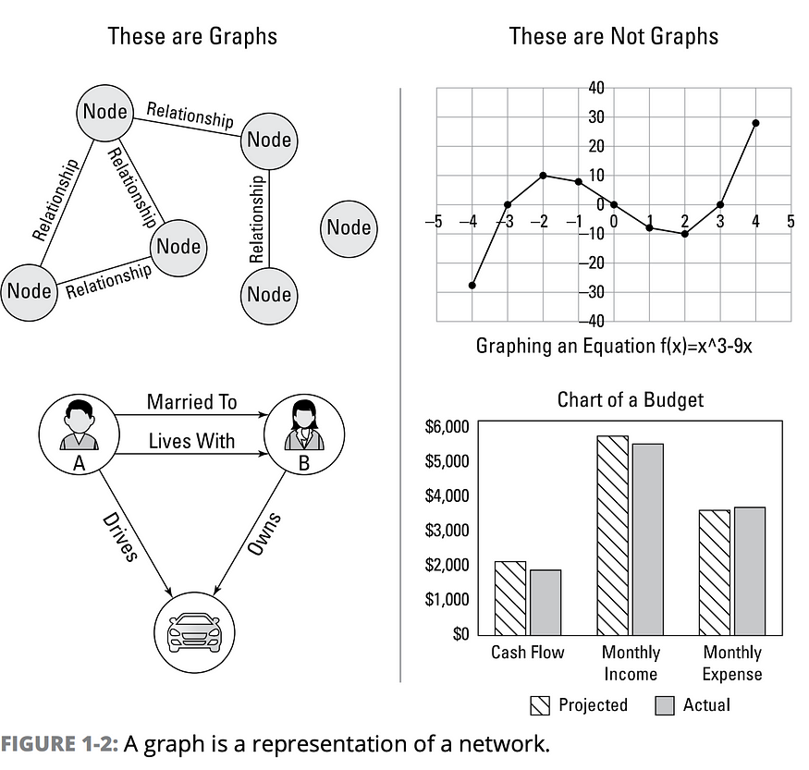
The bottom graph on the left in Figure 1–2 is a person graph. When looking at that graph, you can construct several sentences to describe it. For example, person A lives with person B who owns a car, and person A drives a car that person B owns. This modeling approach maps easily to the real world and is whiteboard friendly, which helps align data modeling and analysis.
We often use the phrase “whiteboard-friendly” for anything that’s easy to describe with simple drawings that you could illustrate on a whiteboard.

Defining Graph Analytics and Graph Data Science
Modeling graphs is only half of the story. You may also want to analyze them to reveal insight that isn’t immediately obvious.
GDS is a science-driven approach to gain knowledge from the relationships and structures in data, typically to power predictions. It uses multi-disciplinary workflows that may include queries, statistics, algorithms, and ML.
GDS can typically be broken down into three areas:
» Graph statistics provides basic measures about a graph, such as the number of nodes and distribution of relationships. These insights may influence how you configure and execute more complex analysis as well as interpret results.
» Graph analytics builds on graph statistics by answering specific questions and gaining insights from connections in existing or historical data. Graph queries and algorithms are typically applied together in “recipes” during graph analytics, and the results are used directly for analysis.
» Graph-enhanced ML and AI is the application of graph data and analytics results to train ML models or support probabilistic decisions within an AI system.
Graph statistics and analytics are often used in conjunction to answer certain types of questions about complex systems and the subsequent insights, applied to improve ML.

Looking at the Types of Questions for GDS
Data scientists try to tackle many types of questions when using GDS to evaluate interdependencies, infer meaning, and predict behavior. At the most abstract level, these questions fall into a few broad areas: movement, influence, groups and interactions, and patterns, as shown in Figure 1–3.
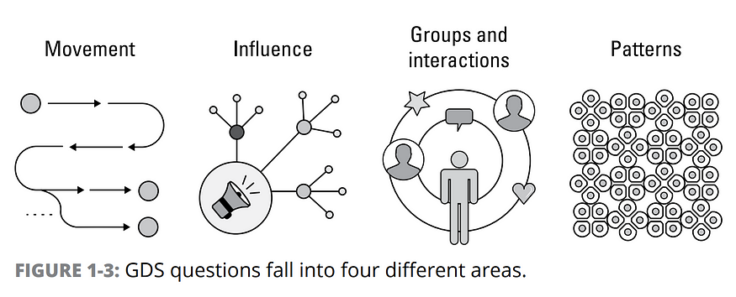
The areas in Figure 1–3 answer the following questions:
» How do things travel (move) through a network? Understanding how things move through a network involves deep path analysis to find propagation pathways, such as the route of diseases or network failures. It can also be used to optimize for the best possible route or for flow constraints.
» What are the most influential points? Identifying influencers involves uncovering the structurally well-placed nodes that represent the control points in a network. These influencers can act as fast dissemination points, bridges between less connected groups, or bottlenecks. Influencers can accelerate or slow the flow of items through networks from finances to opinions. The concept of highly connected and influential nodes in a graph is referred to as centrality. Centrality algorithms are essential for understanding influence in a network.
» What are the groups and interactions? Detecting communities requires grouping and partitioning nodes based on the number and strength of interactions. This method is the primary way to presume group affinity, although neighbor likeness can also be a factor. Link prediction is about inferring future (or unseen) connections based on network structure. Heuristic Link Prediction algorithms are often used to predict behavior. In addition to community detection algorithms, similarity algorithms are also used to understand groupings.
» What patterns are significant? Uncovering network patterns reveals similarities and can also be used for general exploration. For example, you may look for a known relationship pattern between a few nodes or compare attributes of all your nodes to find similarities. Or perhaps you want to evaluate the entire structure of a network, with its intricate hierarchies, to correlate patterns to certain social behavior to investigate. Aggregating related but ambiguous information in large datasets is a common activity that relies on finding similar and related information.
Multiple types of graphs queries and algorithms are usually applied in a recipe fashion as part of a GDS workflow. For example, a query to understand the density of relationships in a graph may help determine the appropriate community detection algorithm for the most relevant results. Tactically, graph queries and algorithms are the tools for understanding the overall nature of a connected system and for using relationships in various data science pipelines.

THE RISE OF GRAPH DATA SCIENCE
The rise of graph data science (GDS) is the result of more accessible technologies, increased ability to compute over massive graph datasets, and an awareness of the power of graphs to infer meaning and improve forecasts. Researchers play an essential role in developing awareness and advocating for the best techniques. As data scientists see the potency of structural information, they’re increasingly incorporating graphs into their statistics, analytics, and ML practices. In fact, according to the Dimensions Knowledge system for research publications, the use of graph technology in AI research is accelerating. In the last ten years, the number of AI research papers that feature graph technology has increased over 700 percent.

Graph technologies help organizations with many practical use cases across industries and domains. In the past, many businesses began exploring graph technology to create a 360-degree view of their customers or to unify master data, including customer, product, supplier, and logistics information. They may use this kind of tracking to improve customer experience or to meet compliance regulations of recent privacy acts such as the EU’s General Data Protection Regulation (GDPR) and the California Consumer Privacy Act (CCPA). This same kind of complete view and data lineage in graphs is also now used to understand and track data used in machine learning (ML) for more responsible artificial intelligence (AI) applications.
Today, businesses are just as likely to look at using graphs specifically for data science as they recognize the predictive power of relationships, the ability to use network structures to improve their ML, and their own need to innovate. The sections in this chapter highlight a few GDS use cases in areas of accelerating growth and significant commercial interest.

Looking at Graphs in Healthcare
It’s easy to see how any industry with biological roots would naturally comprehend the importance of interconnected systems. You can see this relationship in computational biology as well as healthcare and life sciences in how they view challenges as part of larger processes. Two examples stand out for serving health and commercial interests: more efficient drug discovery and better patient outcomes.

Discovering more efficient drugs
Safety, speed, and costs are paramount in making new drug solutions accessible. Graphs can help tackle the complexity of intertwined relationships between diseases, genes, drugs, side effects, and demographics — to name just a few considerations.
One impressive knowledge graph in the life sciences industry integrates over 50 years of biomedical data that includes genes, compounds, diseases, and other information such as symptoms and side effects. One of the projects from the graph predicts new uses for drugs by using the graph topology. The graph helps predict new uses for currently approved drugs by evaluating relationships, network structures, and similarities. Drug repurposing significantly reduces costs and time to market compared to developing and testing new drugs — not to mention the benefit of having more real-world information available about side effects and unexpected results when a drug is already in use.

Improving the patient journey
Another area of emerging interest is the use of graphs for mapping, evaluating, and improving patient journeys. When a patient doesn’t feel well, many factors are in play that may have evolved over a period of time. Likewise, treatments are rarely a single event, especially for chronic or serious illnesses. The tree of possible symptoms, visits, test, care givers, treatment plans, outcomes, and then secondary tests and treatments and so on can branch out into an immense number of possible paths. Imagine the patient treatment options that can be mapped with a graph to better see the sequence alternatives and path splits after each and every test result or visit. In fact, researchers and healthcare providers already employ graphs to better understand what influences patient journeys so they can improve individual outcomes as well as create and compare to optimal paths.

Recommendations and Personalized Marketing
Making relevant product and service recommendations requires correlating product, customer information, historic behavior, inventory, supplier, logistics, and even social sentiment data. Graph-powered recommendations and targeted marketing help companies provide more appropriate services and experiences to a wider range of users. For example, graph community detection algorithms are used to group customers with interactions or similar behavior for more relevant recommendations. Research shows that graph-enhanced ML can predict customer churn, for example, for uses such as targeted prevention or marketing.
Graph analytics are also used to help target offers to online users that are anonymous in name and demographics but not in site behavior. Insights from analysis performed offline are typically rolled into decision models used in production for real-time recommendations, which can include recommendations for products that ship faster based on shifting stock levels or instantly incorporating data from the customer’s current visit.

Fraud Detection
The amount of money lost to fraud each year is growing, despite increased use of AI and ML to detect and prevent it. To uncover more fraud while avoiding costly false positives, organizations look beyond individual data points to the connections and patterns that link them. Organizations use the network structure to augment existing ML pipelines as a practical approach to increase the amount of fraud detected and recovered.
Graph feature engineering allows businesses to extract predictive elements based on graph queries or algorithms and use that information to train ML models. Improving the predictive accuracy in fraud detection even small percentage points can result in tens of millions of dollars saved in just a few months. GDS enables companies to stay ahead of the ever-shifting patterns of fraud as well as recover more losses.

